TECHNICAL PROJECT REPORT

# Title of Invention / Project: INFINITY MIRROR CUBE

# Team Members / Inventors:

|  |  |  |  |  |  |
| --- | --- | --- | --- | --- | --- |
| **S. No.** | **Name** | **Department** | **Designation** | **Mobile** | **E-Mail** |
| 1. | SHAHBAAZ SINGH GILL | CSE IBM IS1 | STUDENT | 8437239992 | gill.shahbaaz6@gmail.com |
| 2. | Jai Kishan | CSE IBM IS1 | STUDENT | 7728055004 |  |
| 3. | Anshuman Gupta | CSE IBM IS1 | STUDENT | 9577123000 |  |
| 4. | Antriksh Sharma | CSE IBM IS1 | STUDENT | 9419156395 |  |
| 5. | Yadlapalli Krishna Vaibhav | CSE IBM IS1 | STUDENT | 8897116069 | krishvaibhav@gmail.com |
| 6. | Anshul Sharma | ECE | Mentor | 9478697475 | anshulsharma.ece@cumail.in |
| 7. | Kiran Jot Singh | ECE | Mentor | 9463909689 | kiranjotsingh.ece@cumal.in |
| 8. | Divneet Singh Kapoor | ECE | Mentor | 9878422653 | divneet.ece@cumail.in |

Section – 1 (IPR Related)

# Brief Abstract: Infinity mirror cube is a showpiece which is a very pleasant object to look at especially at night or in the dark. along with looking extremely radiant it also releases stress and pumps up the mood of an individual. the making of the cube is very complex, it includes six mirror pieces joined together by adhesive material. THE CUBE WHEN FORMED GIVES A LOOK OF INFINITE LIGHTING WHICH IS VERY APPLEALING TO LOOK. MOREOVER, THE LEDs COME WITH A VARIETY OF COLOUR SCHEMES WHICH ARE CONTROLLED BY A REMOTE CONTROL AND THEIR INTENSITY CAN ALSO BE CHANGED.

# Existing state-of-the-art and Drawbacks in existing state-of-the-art

|  |  |  |
| --- | --- | --- |
| **S. No.** | **Existing state of art** | **Drawbacks in existing state of art** |
| 1 | SIX MIRRORS WRAPPED IN ACRYLIC SHEETS | THE SHEETS HAVEN’T BEEN APPLIED PROPERLY |
| 2 | THE MIRRORS ARE IN THEIR INDEPENDENT STAGE WITHOUT LEDs | THIS DOESN’T SHOW THE INFINITY EFFECT, NOT MAKING IT AN INFINITY MIRROR CUBE. |

# Novel/Additional modifications that you can propose to improve upon drawbacks

* RE-APPLY THE SHEETS NEATLY TO MAKE IT MORE PLEASING TO LOOK
* JOIN THE MIRRORS TO MAKE A CUBE AND FIX THE LEDs IN THEIR POSITION

# Advantages

* PLEASING TO LOOK AT
* ENHANCES THE MOOD

# Block Diagram

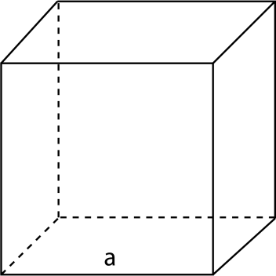 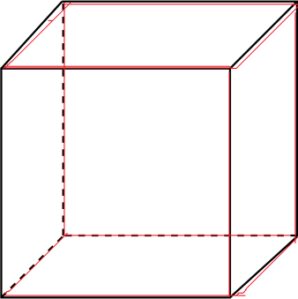

Section – 2 (Real Project)

# Materials

MIRRORS, ACRYLIC SHEETS, SUPERGLUE, LED STRIP

# Circuit Diagram OF LEDs

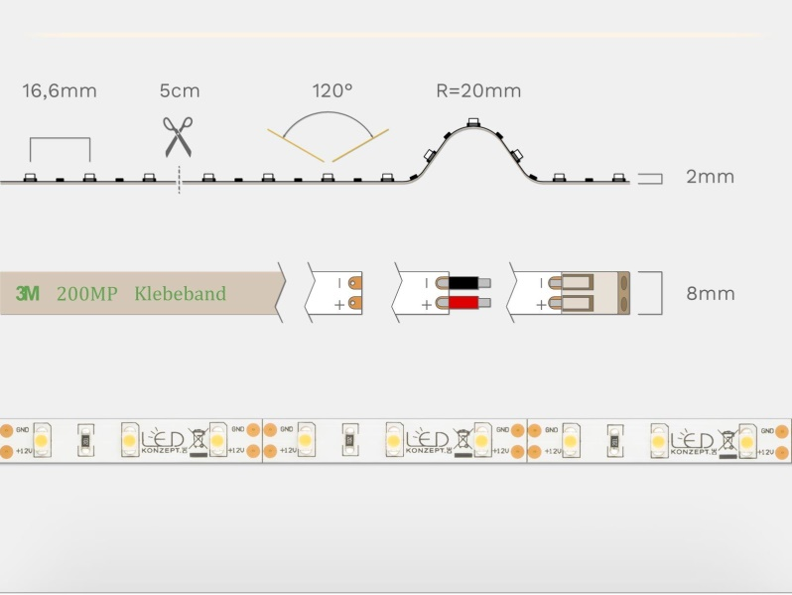

# Steps of Circuit Completion

NA

# Program Code

(*Link of your Github project*)